# LAB REPORT

# Lab 2: Familiarization with Equipment and Basic Cruise Control Design

# Lab Date: Monday November 4, 2019

# Submission Date: Monday November 11, 2019

# Prelab: 1 marks

# Lab Report: 4 marks

# Lab Work: 5 marks

|  |  |
| --- | --- |
| Name | Student Number |
| Bingran Li | 1004191910 |
| Omar ElZaria | 1004095739 |
|  |  |

## 4.2 Identification of model parameters

(0.25 mark) Find the relationship between the parameters *a* and *b*:

(Provide a derivation of this relationship based on your experimental observations)

$$a=\frac{Δv}{V_{o}}b=\frac{0.86}{6}b$$

(0.25 mark) The values of *a* and *b* found experimentally are: a = 0.788 b = 5.5

## 4.3 Proportional Control

(0.25 mark) Does the P controller successfully regulate the speed to the desired value?

No

(1 mark) What’s the effect of increasing the gain K on the output response? Explain what is, in your opinion, the reason for the effect you have observed.

It brought the velocity closer to a square wave, but there is still visible error in terms of the amplitude of velocity. This is because with the proportional controller, the transfer function becomes $\frac{aK}{s+b+aK}$, and when K gets larger, the transfer function becomes closer to being 1, and the error decreases.

(0.75 mark) Plot the “P controller” experimental results; containing the measured velocity and the reference signal(with proper labels).

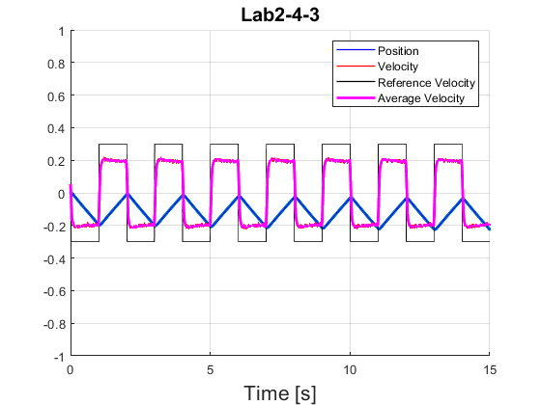

## 4.4 Proportional-Integral Control

(1.25 mark) How does the performance of the P and PI controllers compare? Explain the differences you observe and explain what is the reason for such differences?

The PI controller has much less error when compared to the P controller, this is due to the fact that the integration part of the PI controller accumulates the error along the way and compensates for it in the control function

(0.5 mark) What’s the effect of increasing the gain K?

Increasing the gain K brings the average velocity closer to the reference velocity

(0.75 mark) Plot the “PI controller” experimental results; containing the measured velocity and the reference signal(with proper labels).

